GLA UNIVERSITY
Department of Computer Engineering & Applications
MINI PROJECT – 1 SYNOPSIS
1. BASIC PROJECT DETAILS
Project Title | Application & Status Tracking Portal
Batch No. | B-12
Section | AE-3
Semester | 5th Semester
Date of Submission | [Date of Submission]
Faculty Mentor / Guide | [Faculty Mentor Name]
2. TEAM MEMBERS & ROLES
List every team member, their university roll number, and their specific role/responsibility in the project (e.g., Frontend Development, UI/UX Design, Backend & API, Testing & Documentation, Research & Presentation).
S.No. | Name of Student | University Roll No. | Role in Project
1 | Surya Prakash Singh | 2415001638 | Frontend Development
2 | Suyash Dwivedi | 2415001646 | Backend & API Development
3 | Tanmay Pathak | 2415001663 | UI/UX Design
4 | Teekesh Faujdar | 2415001681 | Testing & Documentation
5 | Tushit Mishra | 2415001691 | Research & Presentation
3. PROJECT DESCRIPTION
Briefly describe what the project is about — the problem it addresses and the core idea behind it (150–200 words).
In most colleges and organizations, applicants have no clear way to track the status of their submitted applications, leading to repeated queries and confusion for both applicants and administrators. This project proposes an Application & Status Tracking Portal that models an applicant's entire journey — document submission, review, and final decision — as a client-side state machine built over a bundled dataset, removing the need for a live backend during development and demonstration. Each application moves through clearly defined stages such as Submitted, Under Review, Documents Pending, Approved, and Rejected, with all transitions governed by explicit state-machine rules, so an application can never jump to an invalid stage or skip a required check.
The interface displays an animated progress tracker so applicants can visually follow their status at a glance, along with a document checklist that lets them tick off submitted items, with progress persisted locally in the browser so it survives page refreshes. On the administrative side, a Kanban-style board lets staff drag and drop application cards between stage columns, instantly updating each applicant's state and re-rendering their tracker in real time.
The project's core learning goal is to model complex, multi-stage workflows purely in the frontend — using finite state machines, reusable UI components, drag-and-drop interaction, and local persistence — while keeping the codebase structured enough to later swap the bundled dataset for a real backend with minimal changes.
4. OBJECTIVES & PROPOSED WORK (WHAT WE ARE GOING TO DO)
Explain the key features you plan to build, the technology/approach you will use, and the current stage of work. Use bullet points if needed.
Design and implement a client-side finite state machine to model each application's lifecycle (Submitted → Under Review → Documents Pending → Approved/Rejected), with guarded transitions that prevent invalid state changes.
Build an animated, per-application progress tracker UI that visually reflects the current stage, highlights the active step, and transitions smoothly between states using CSS/JS animation.
Develop a document checklist component where applicants can tick off required documents, with progress saved via local persistence (localStorage) so it is retained across sessions.
Create an admin-facing Kanban board where applications can be dragged and dropped between stage columns to update their status, with instant visual feedback and undo support.
Structure the project around a bundled/mock JSON dataset of applications to simulate real-world data without requiring a live backend, while keeping the data layer decoupled for future API integration.
Use a modern frontend stack (React, a drag-and-drop library such as dnd-kit, and Framer Motion for animation) to build a responsive, accessible, and interactive interface.
Ensure state transitions are validated (e.g., an application cannot move to Approved without completed documents) and reflected consistently across both the applicant and admin views.
Current stage: requirements finalized, state-machine design and UI/UX wireframes for both applicant and admin views are complete, and component development is underway.
5. FUTURE SCOPE / ENHANCEMENTS
Describe what you plan to add or improve in the future beyond the current scope of the project.
Integrate a real backend (Node.js/Express with a database such as MongoDB or PostgreSQL) to replace the bundled dataset and support persistent, multi-user data across sessions and devices.
Add authentication and role-based access control so applicants and admins have separate, secure logins with permissions scoped to their role.
Introduce email/SMS notifications to automatically alert applicants whenever their application stage changes, reducing the need for manual status checks.
Add analytics and reporting for admins, such as average processing time per stage, bottleneck detection, and exportable reports for audits.
Support real file uploads for actual documents instead of a simple checklist, with type/size validation, previews, and secure cloud storage.
Make the portal fully responsive, add multi-language support, and deploy it as a hosted web application accessible to real applicants and admins.
6. TOOLS & TECHNOLOGIES USED
Frontend: React.js, JavaScript (ES6+), HTML5, CSS3, a drag-and-drop library (react-beautiful-dnd / dnd-kit), Framer Motion for animation, Recharts (for any future admin analytics)
Data & Persistence: Bundled JSON dataset, Browser localStorage | Tools: Git/GitHub, VS Code, Figma (UI design), ESLint/Prettier for code quality
7. EXPECTED OUTCOME
Summarize the expected result/deliverable of the project.
A fully functional web-based Application & Status Tracking Portal that lets applicants view an animated, real-time progress tracker for their application and tick off required documents with locally persisted progress. Administrators will be able to manage all applications through an interactive Kanban board, moving them between review stages with drag-and-drop actions and seeing every change reflected instantly on the applicant side.
The final deliverable will demonstrate solid understanding of client-side state management, finite state machines, UI/UX design, drag-and-drop interaction, and local data persistence — forming a strong, portfolio-ready foundation that can later be extended into a production-grade, backend-connected system.
8. WORKFLOW DIAGRAM
High-level flow of an application through the client-side state machine, the applicant-facing UI, and the admin Kanban board.
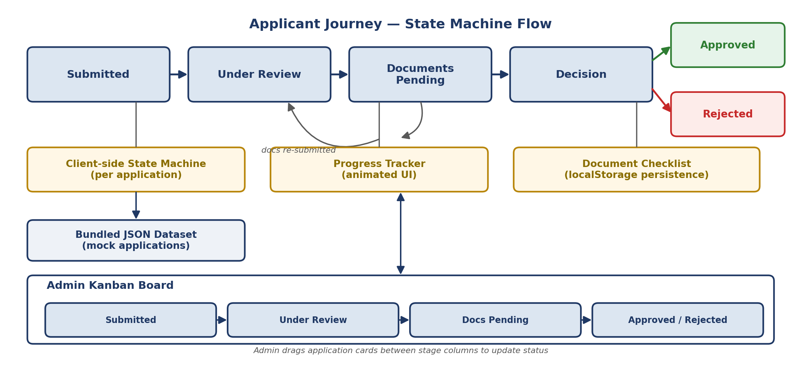

Signature of Faculty Mentor

